**DBDesigner/ERD Lab Manual**

1. Go to this website: [**https://app.dbdesigner.net/academic-registration**](https://app.dbdesigner.net/academic-registration)**.**
2. Fill in your details accordingly. Make sure you set **Select Role** to **Student**, and set **Institute URL** to [**https://www.iba.edu.pk/.**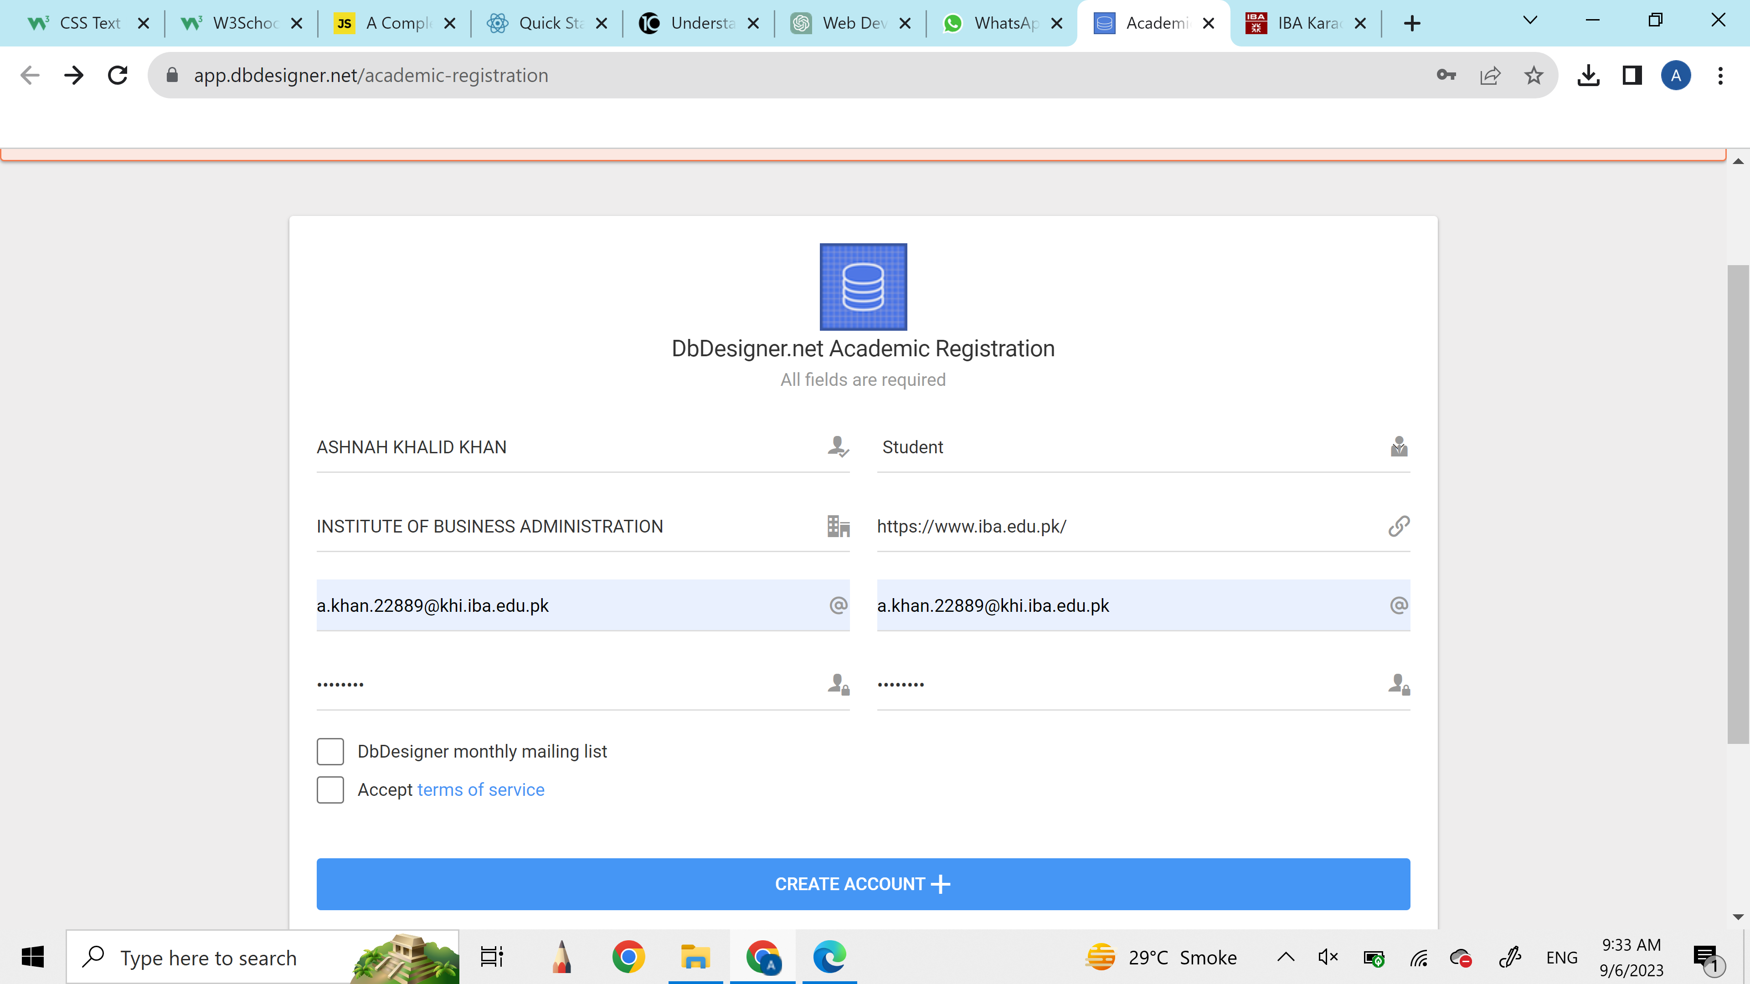](https://www.iba.edu.pk/.)
3. Click on **CREATE ACCOUNT+.**
4. You should now have been navigated to your Dashboard. Click on **NEW PROJECT** near the top right of your screen.

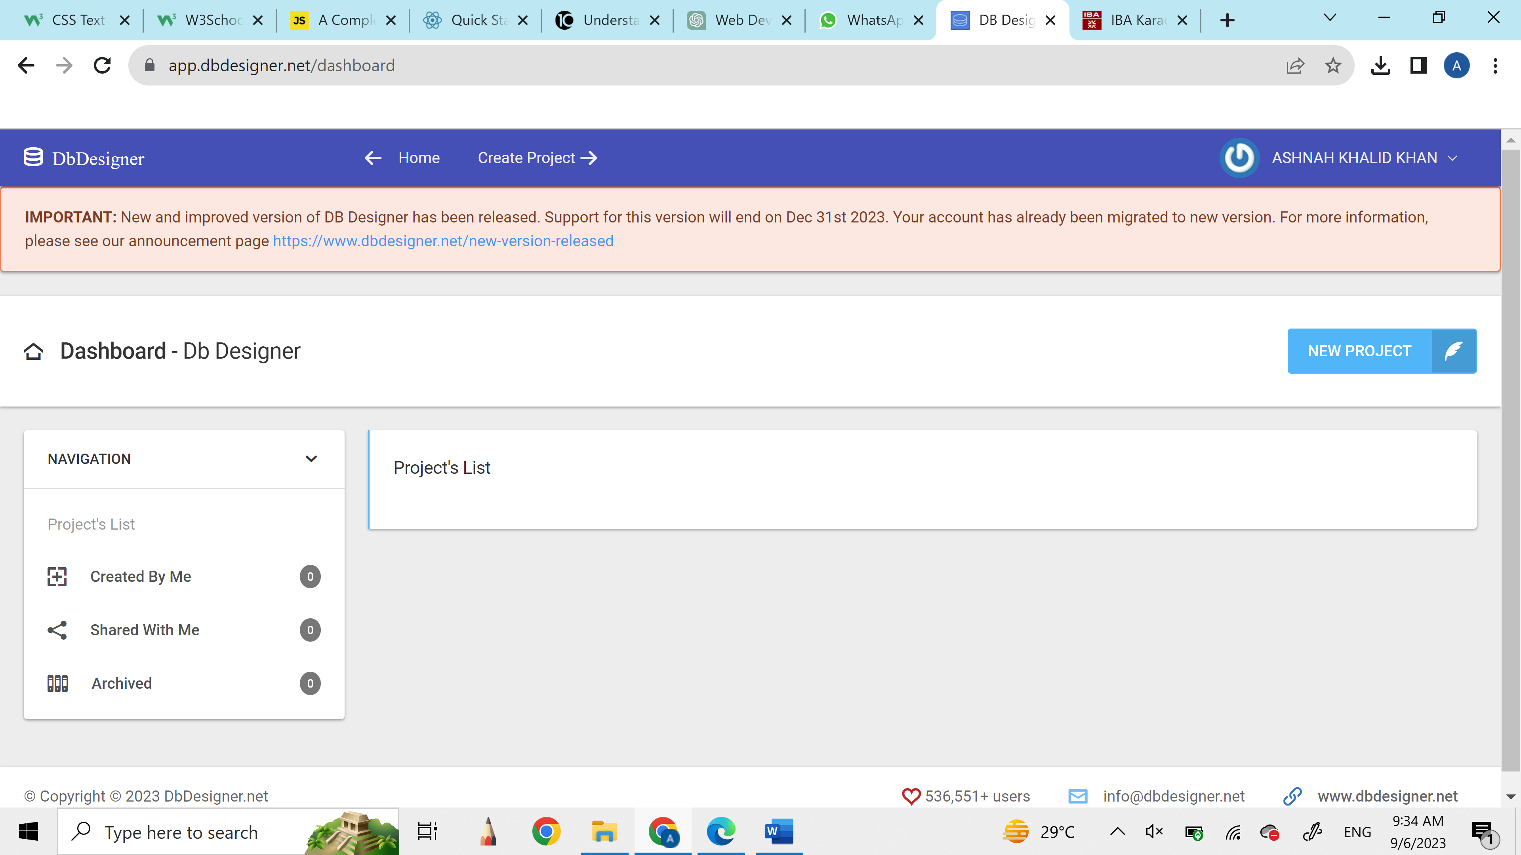

1. You should be able to view your workspace. This is where you will create your ERD.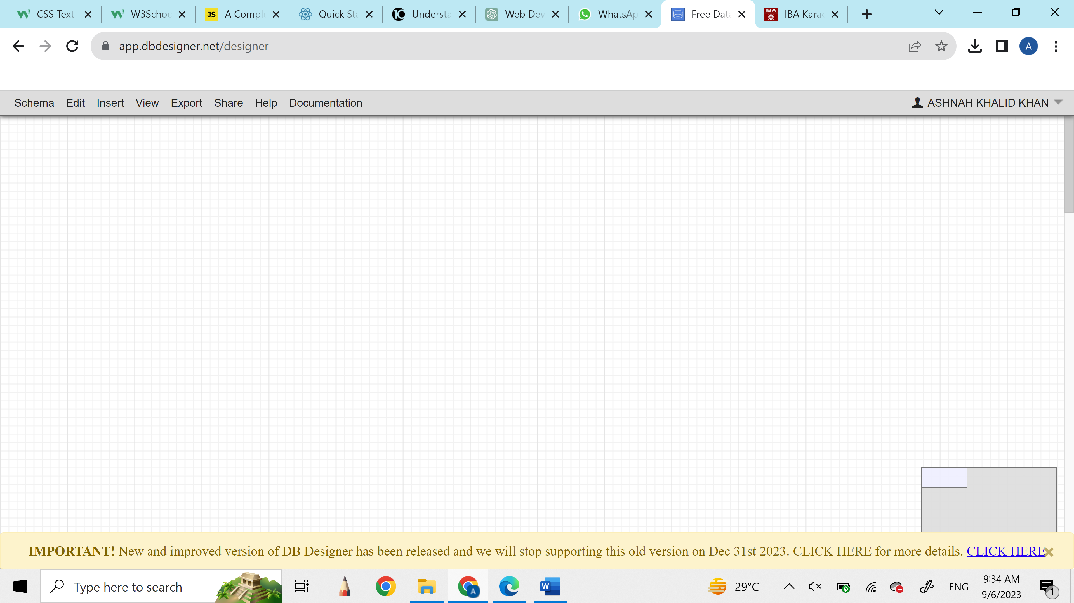
2. To insert a table, go to the top left tabs on your screen and click on **Insert.**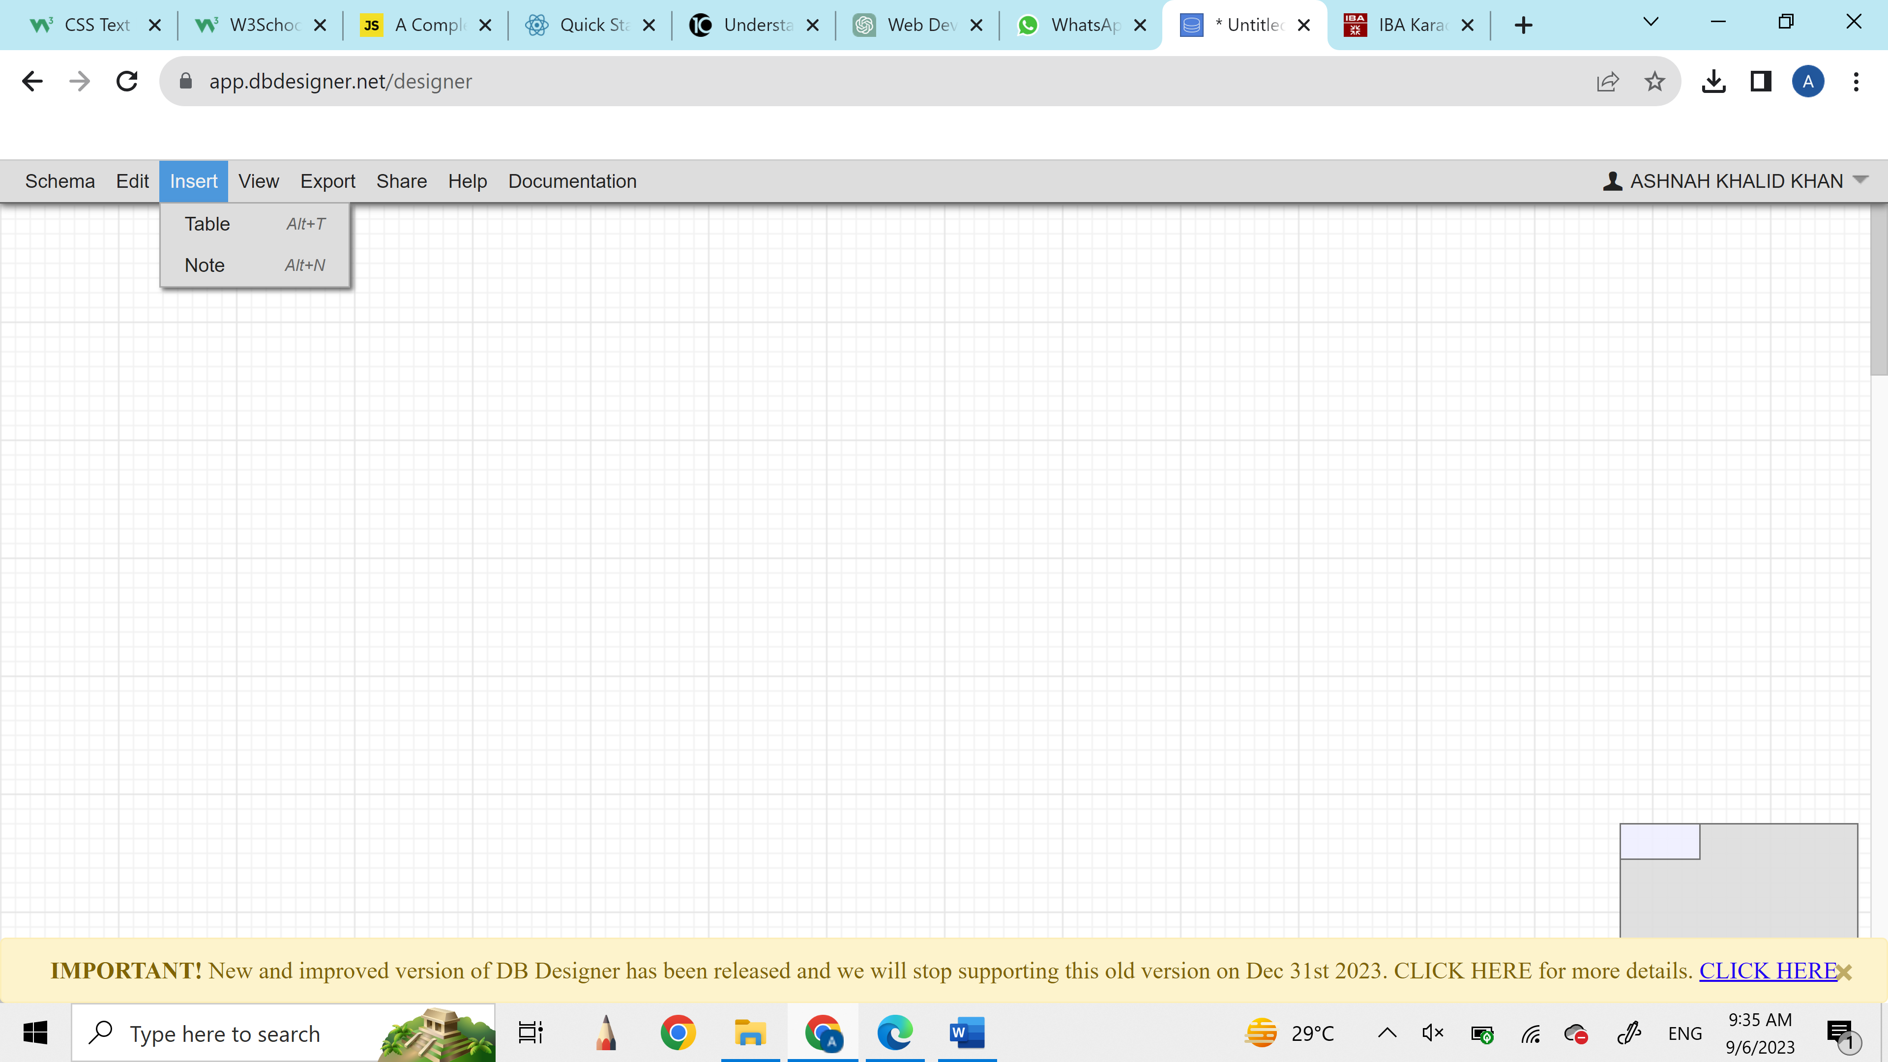
3. Then click on **Table.** 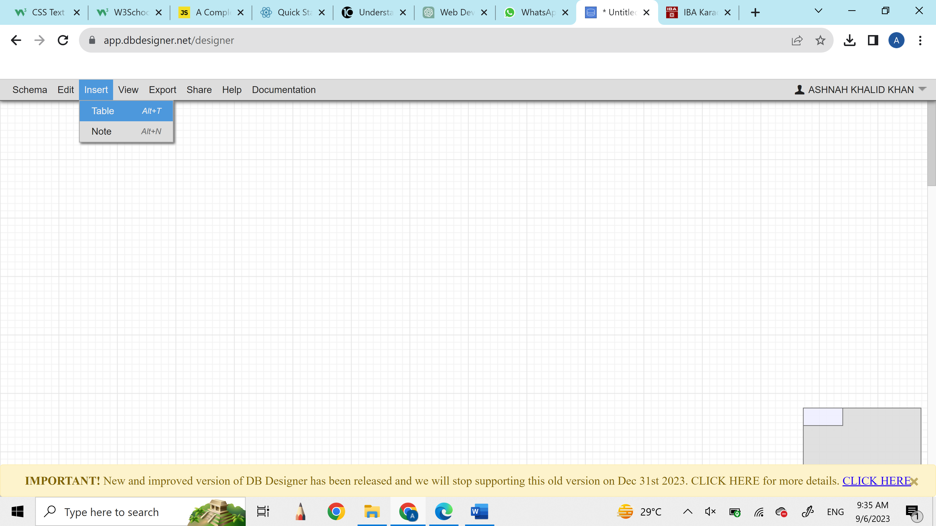
4. This should insert a blank table into your workspace.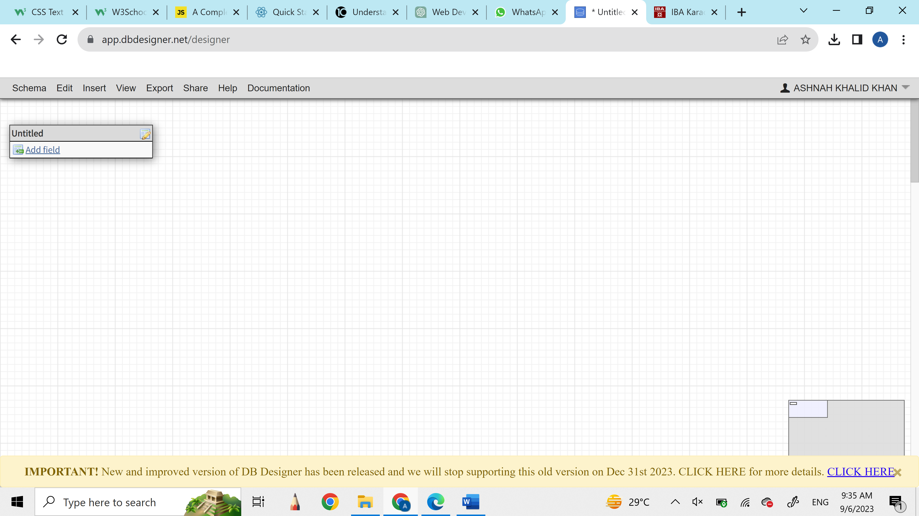
5. To modify the table, click on the top-right pencil edit icon on the table.
6. You can now assign a name to the table e.g. *Customers.*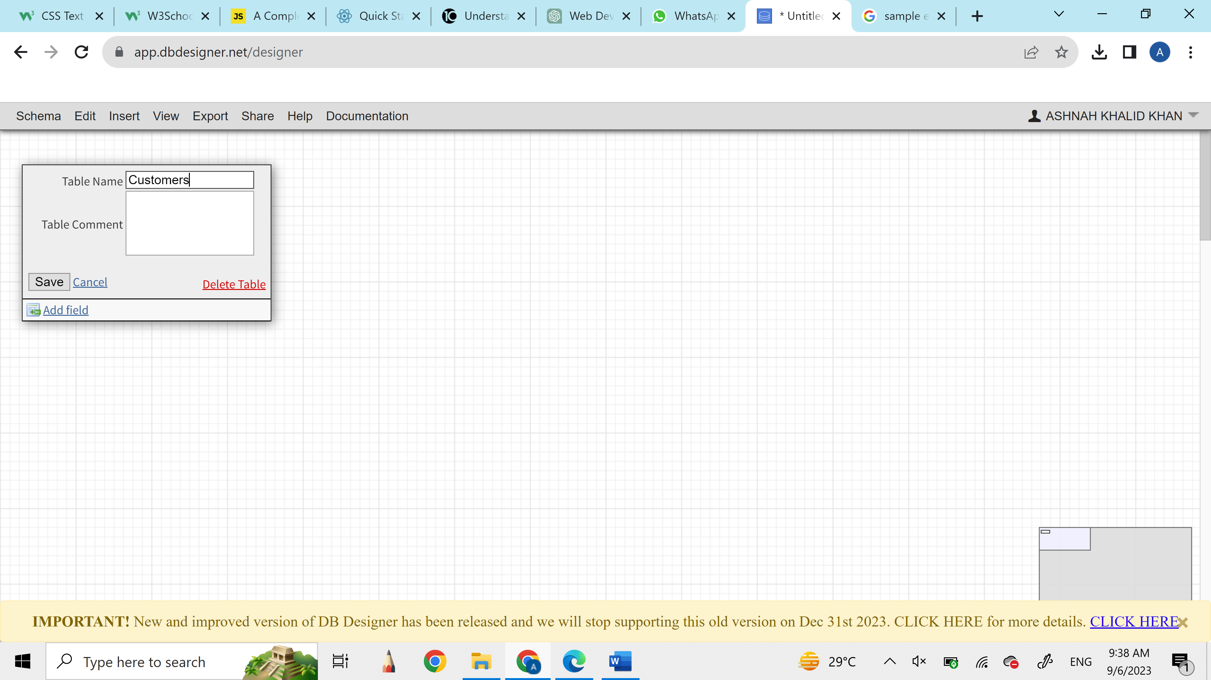
7. To add columns into your table, click on the bottom-left on **Add field.** 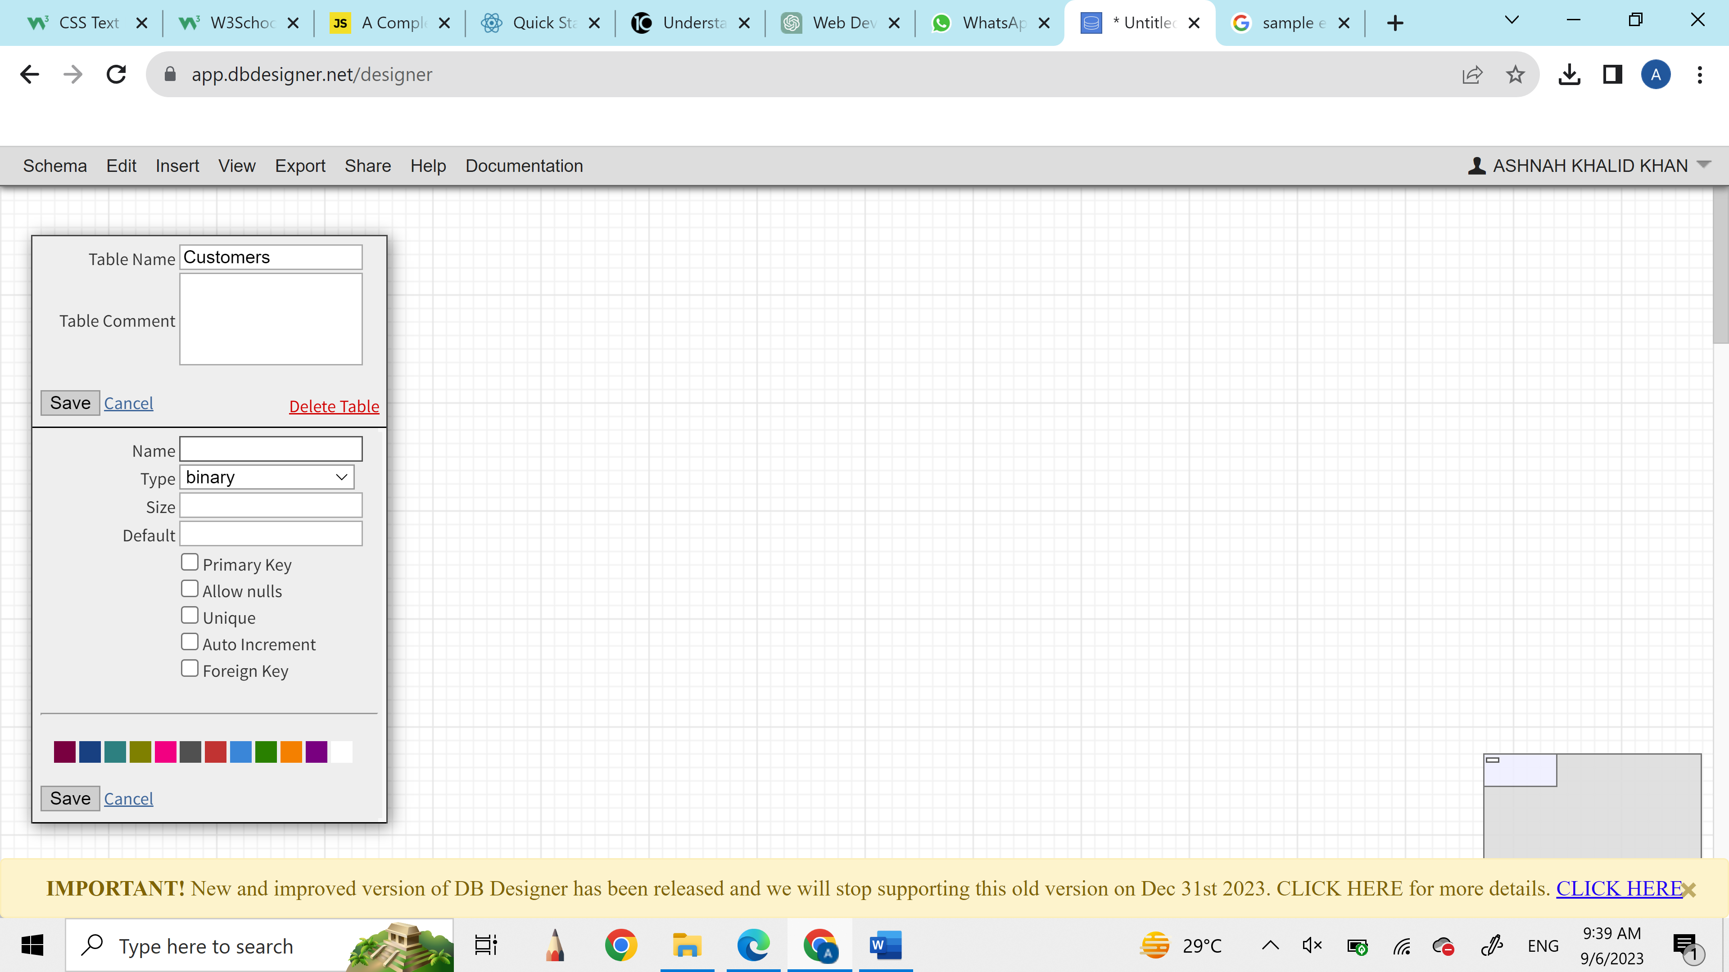
8. Write the name, select the data type and set the size or default value for the column e.g. *Customer_ID, varchar, 255.* 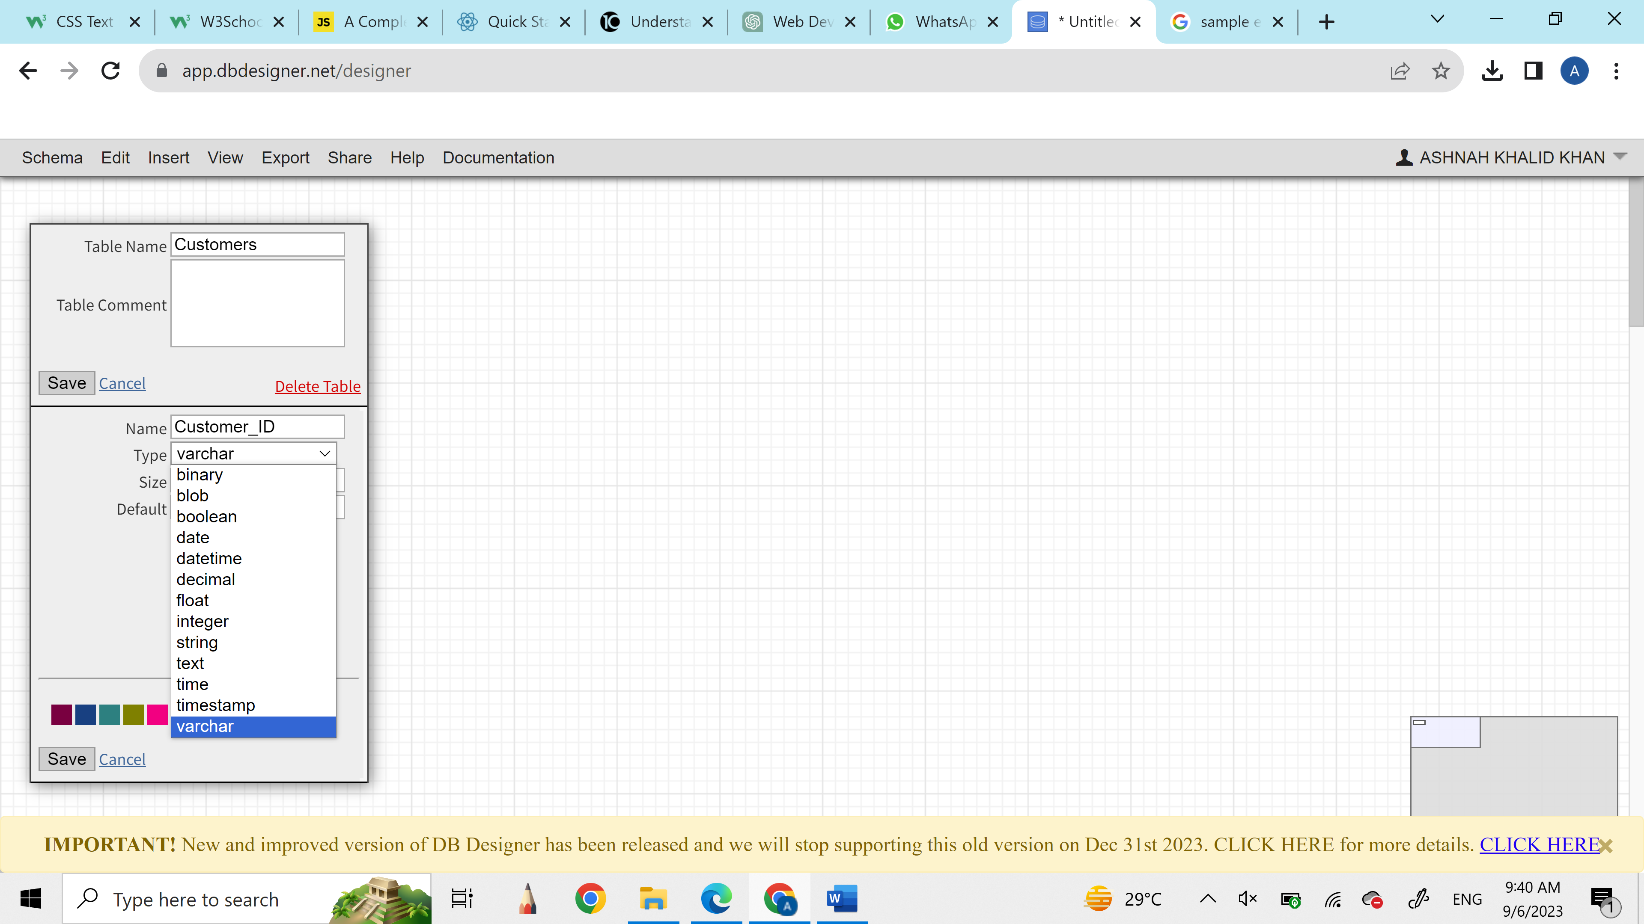
9. To add constraints to the column e.g. PRIMARY KEY, UNIQUE, NOT NULL etc, select the relevant checkboxes. 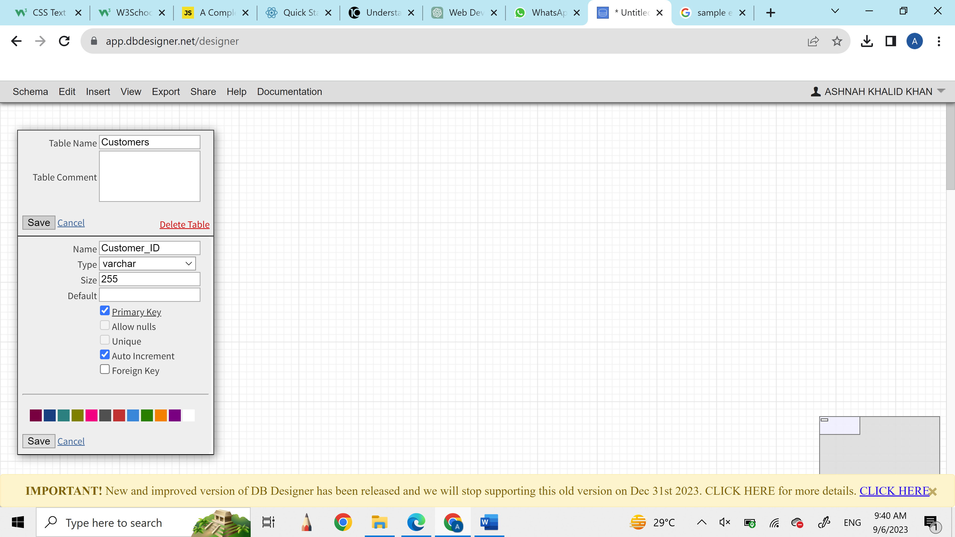
10. Click both **Save** to save the table and field. 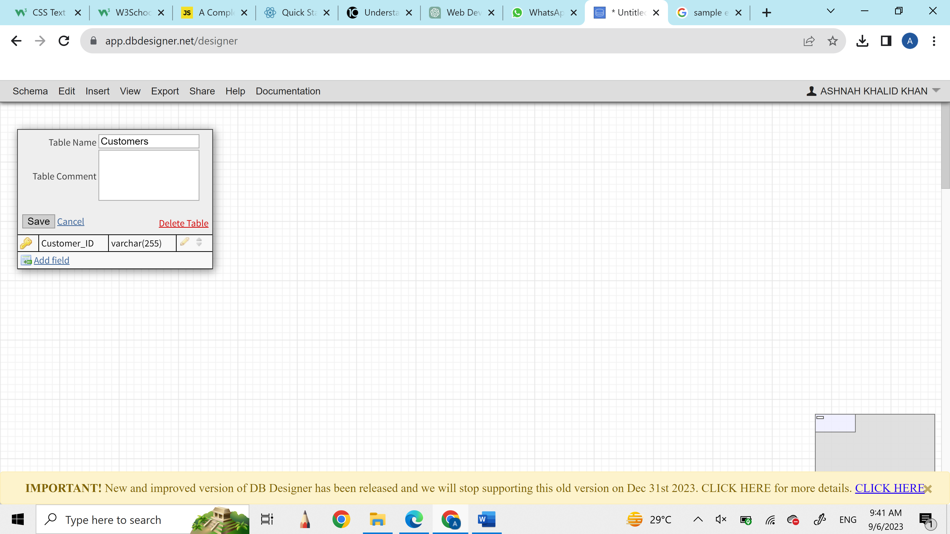
11. To reference a foreign key from another table, first make the other table e.g. *Locations* table with the field *Location_ID.* 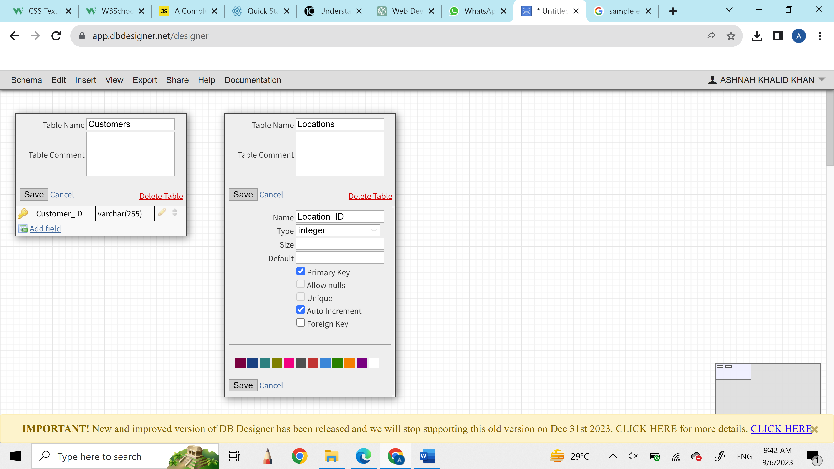
12. You must now have two tables with the following fields.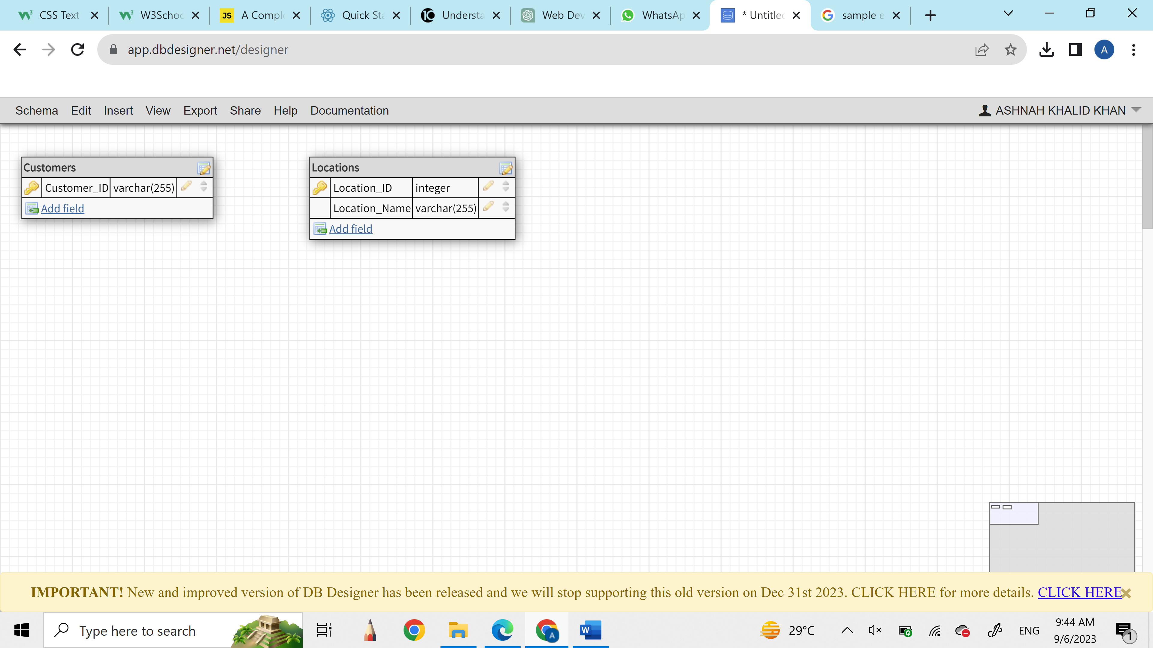
13. Now add another column to the table you want to reference a column too. In this example, *Customers* table contains the *Location_ID* column that references the *Location_ID* column from the *Locations* table.
14. Select the **Foreign Key** checkbox and select the table you want to reference the column from in the **Ref. Table** and **Ref. Field** respectively.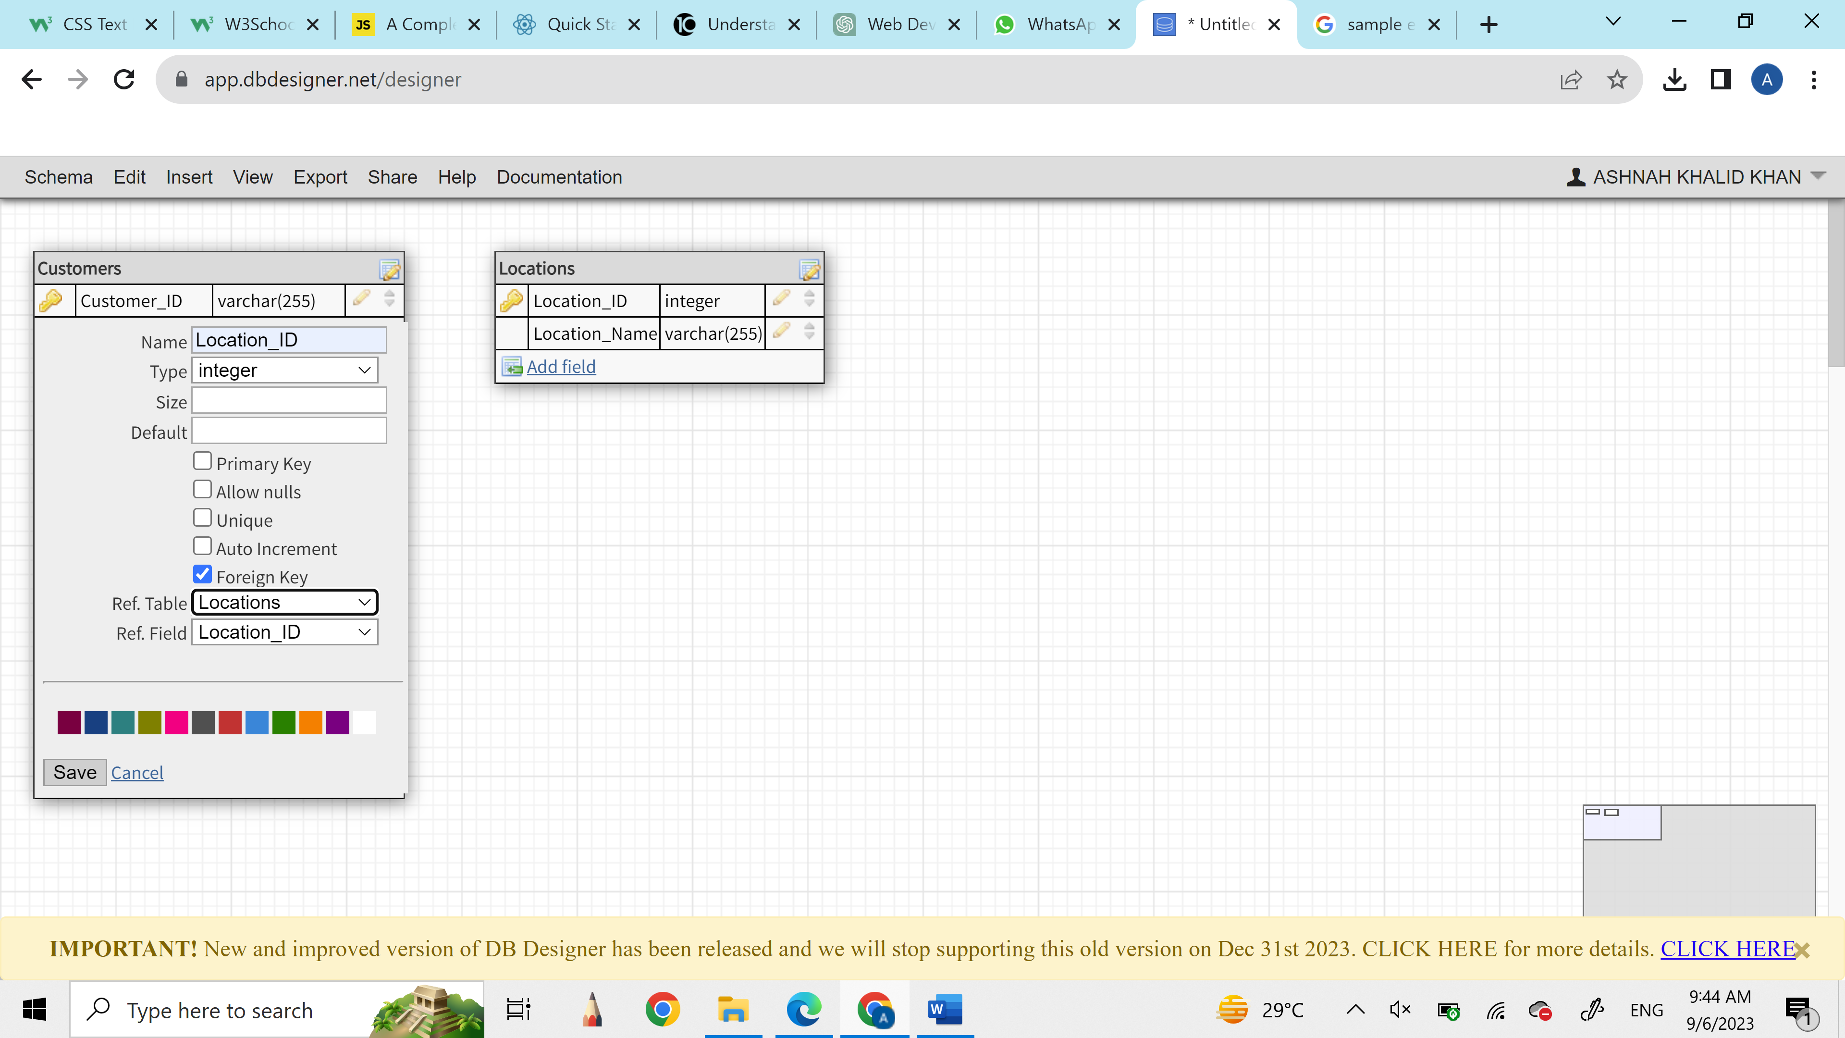
15. Foreign Key has been successfully referenced if you can view the arrow from your table to your referenced table like shown below.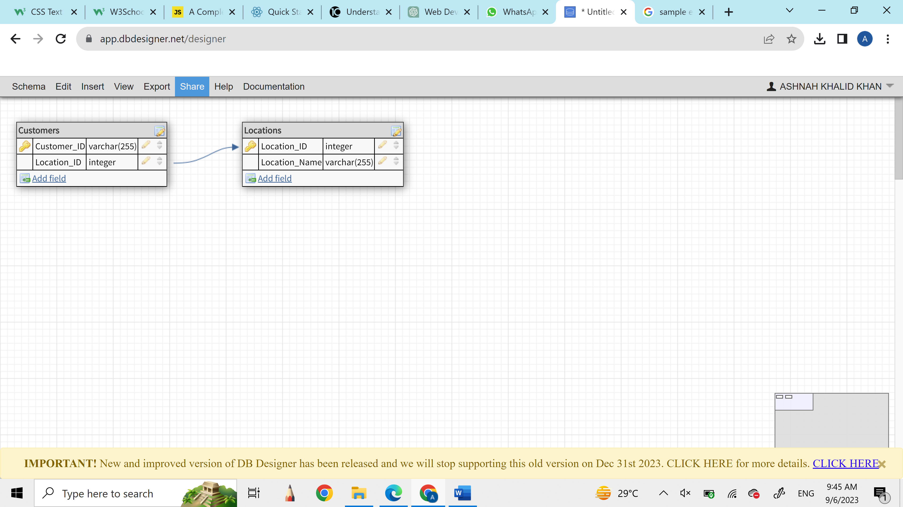
16. To export the DDL SQL queries for your created ERD, go to the top left tabs on you screen and click on **Export.** 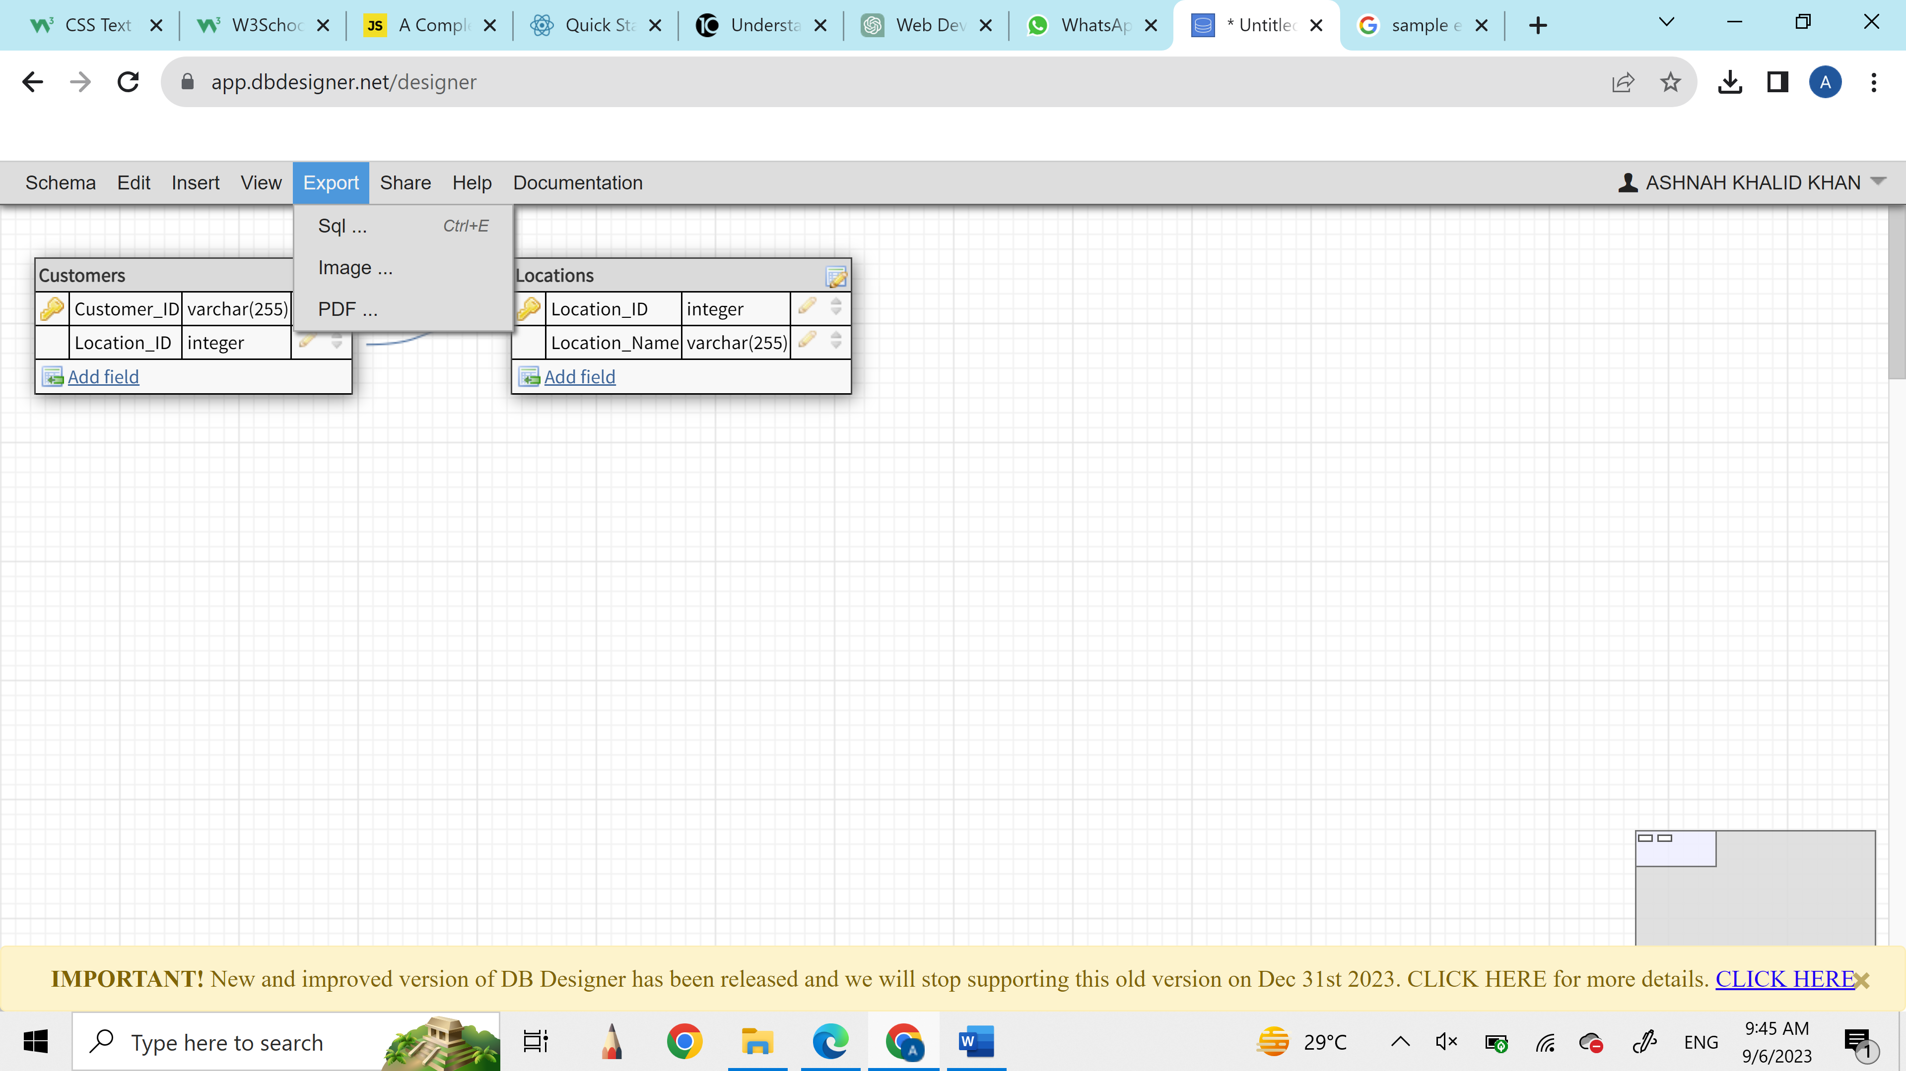
17. Select **Oracle** to export DDL SQL queries that are compatible with Oracle database. 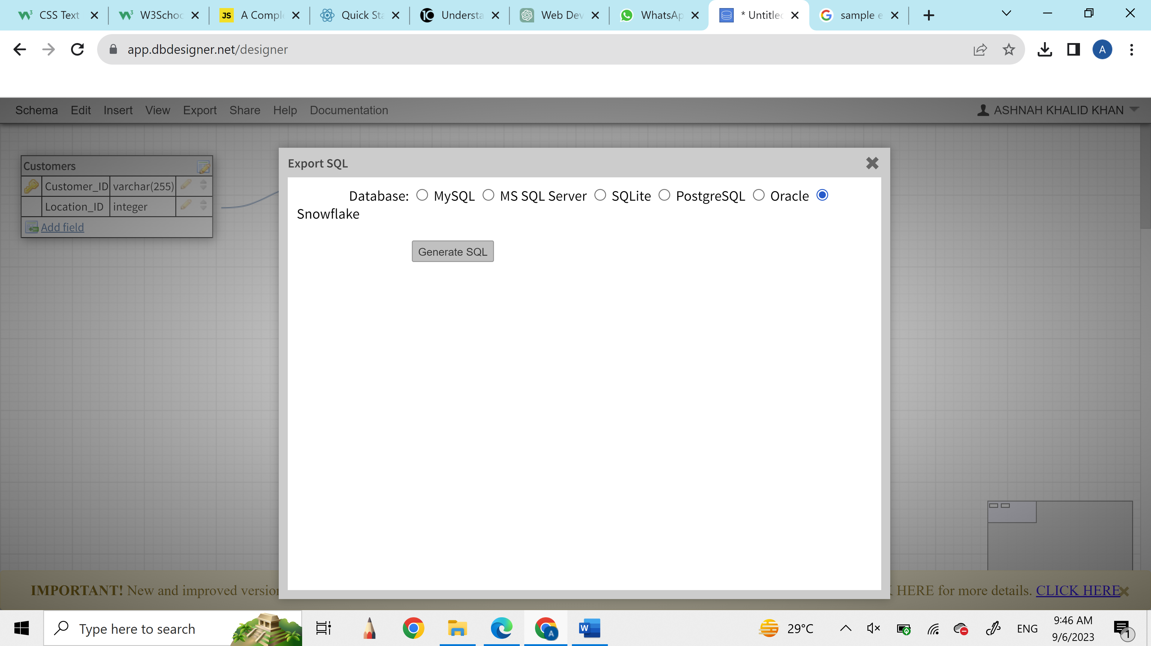
18. The DDL SQL queries have now been generated.
19. To save the code, click on **Download SQL file.** 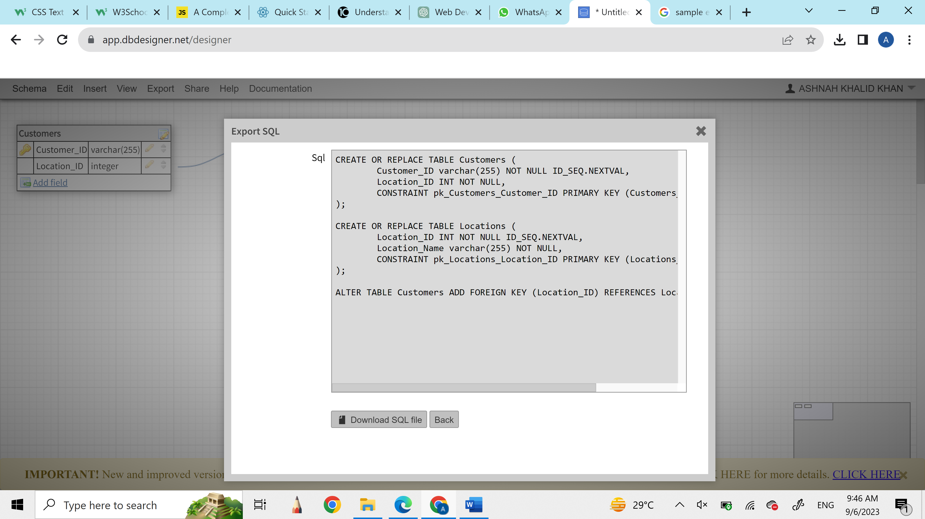
20. To save your ERD on DBDesigner, click on **Schema.** 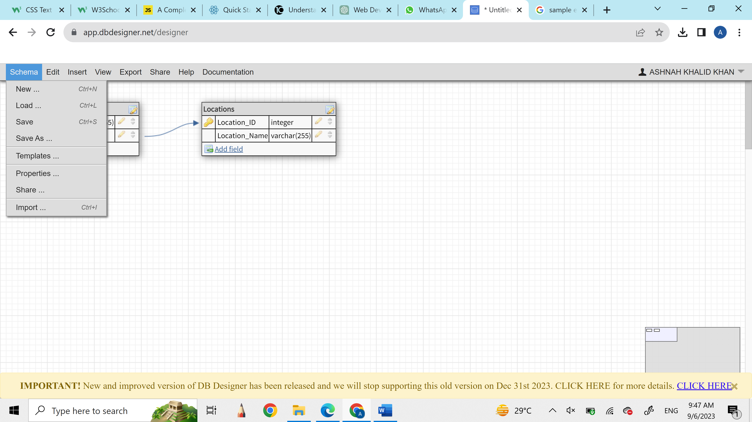
21. Then click on **Save As.** 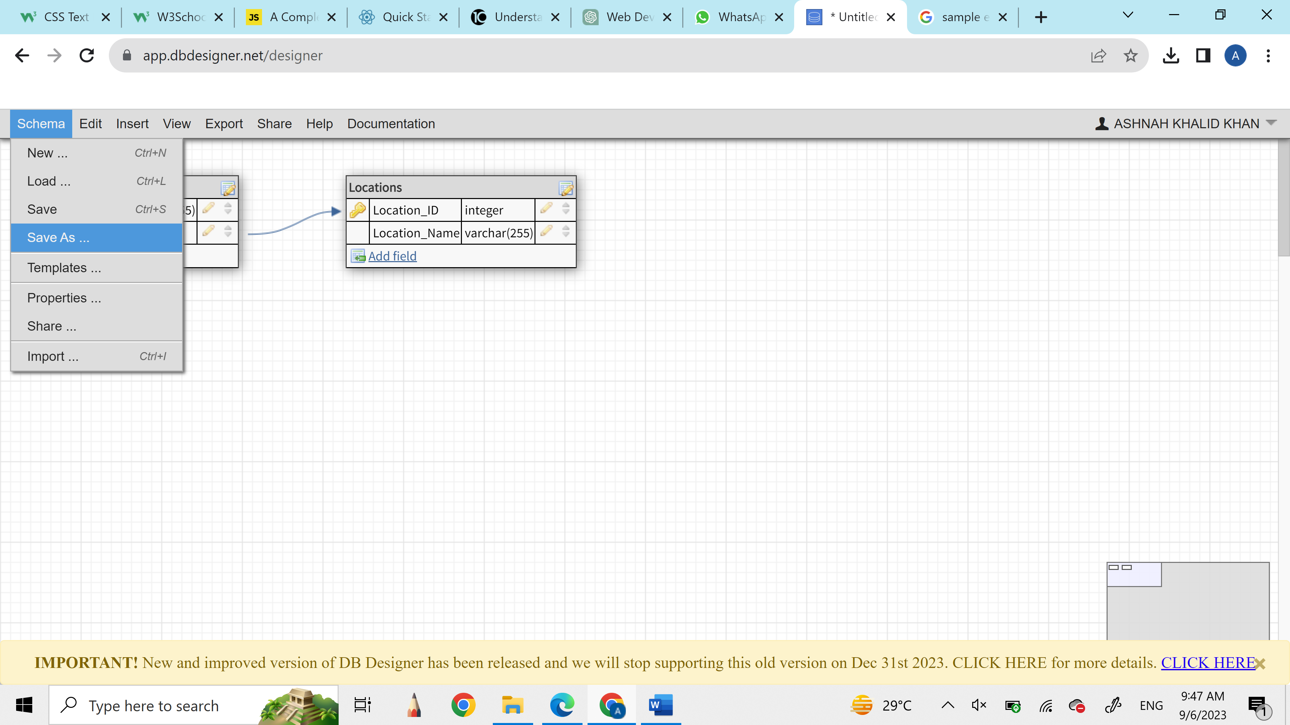
22. Give a title to your ERD and click on **Save As.**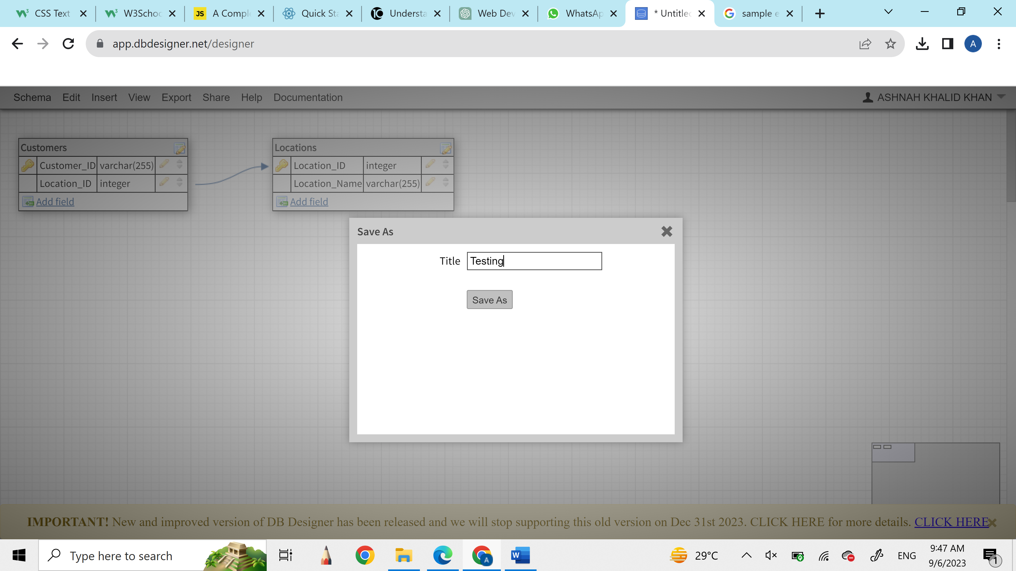
23. Your ERD is now saved!